**DSpace 6.x with Mirage2 Installation**

**Edit Source List**

Add the following commands in /etc/apt/sources.list

deb http://deb.debian.org/debian stretch main

deb-src http://deb.debian.org/debian stretch main

deb http://deb.debian.org/debian stretch-updates main

deb-src http://deb.debian.org/debian stretch-updates main

deb http://security.debian.org/debian-security/ stretch/updates main

deb-src http://security.debian.org/debian-security/ stretch/updates main

without adding this source list below packages will find unable to locate candidate

**Run the following commands**

$ apt-get update

$ apt-get upgrade

$ apt-get install openjdk-8-jdk -y

$ apt-get install ant ant-optional maven -y

$ apt-get install tomcat8 -y

$ apt-get install postgresql postgresql-client

$ apt-get install perl

**Set up Environment**

Open “/etc/environment” file and add the following

$ nano /etc/environment

JAVA_HOME="/usr/lib/jvm/java-8-openjdk-amd64"

JRE_HOME="/usr/lib/jvm/java-8-openjdk-amd64/jre"

CATALINA_HOME="/usr/share/tomcat8"

CATALINA_BASE="/var/lib/tomcat8"

TOMCAT_HOME="/usr/share/tomcat8"

JAVA_OPTS="-Xms512m –Xmx1024m -Dfile.encoding=UTF-8"

**Create a sudo DSpace user**

$ adduser dspace

$ passwd dspace

$ usermod -aG sudo dspace

**Create Database**

psql -U user_name -h 127.0.0.1 -d db_name

$ su - postgres

$ createuser dspace

$ createdb dspace -E UNICODE

$ psql -d dspace

$ CREATE EXTENSION pgcrypto;

$ ALTER ROLE **dspace** WITH PASSWORD '**01964**';

$ ALTER DATABASE **dspace** OWNER TO **dspace**;

$ GRANT ALL PRIVILEGES ON DATABASE **dspace** TO **dspace**;

$ /etc/init.d/postgresql reload

**Mirage2 Prerequisites Installations**

$ apt-get install git  
 $ curl -o- https://raw.githubusercontent.com/creationix/nvm/v0.33.11/install.sh | bash

Before proceeding, open a different shell session and type the command below just to ensure that nvm installed correctly. If you used the above installation command without changing the version bit, it should output 0.33.11. You must exit the shell session you used to install and reopen a different one before proceeding.

$ nvm --version

$ nvm install node

$ npm install -g bower

$ npm install -g grunt && npm install -g grunt-cli

$ curl -sSL https://get.rvm.io | bash -s stable --ruby

NOTE: If you encounter key verification errors during this step, run the command below:

$ curl -sSL https://rvm.io/mpapis.asc | gpg --import -

sudo gpg --keyserver hkp://pool.sks-keyservers.net --recv-keys 409B6B1796C275462A1703113804BB82D39DC0E3 7D2BAF1CF37B13E2069D6956105BD0E739499BDB

$ gem install sass -v 3.3.14 && gem install compass -v 1.0.1

**Preparing directories**

$ mkdir /dspace

$ chown -R dspace:tomcat8 /dspace

$ mkdir /build

$ chmod -R 777 /build

$ chown -R dspace /build

**Downloading DSpace 6.x Source file**

Switch to user **dspace** and continue as such till installation

$ su - dspace

$ cd /build

$ wget -c <https://github.com/DSpace/DSpace/releases/download/dspace-6.3/dspace-6.3-release.tar.gz>

$ tar -zxvf dspace-6.3-release.tar.gz

$ cd dspace-6.3-release

**Initial configuration**

At this point, we only need to define the installation directory. To do this, we need to create the configuration file using the initial file provided at [**dspace/config/local.cfg.EXAMPLE**]

$ cp dspace/config/local.cfg.EXAMPLE dspace/config/local.cfg

$ nano dspace/config/local.cfg

Edit the dspace.dir setting as shown below:

$ dspace.dir=/dspace

192.168.48..101

**Enable Mirage2 theme**

Enable Mirage2 theme opening **dspace/config/xmlui.xconf** and locate **<themes>** section and comment out the active Mirage theme and enable Mirage2 theme as shown below:

<!-- <theme name="Atmire Mirage Theme" regex=".*" path="Mirage/" /> -->

<theme name="Atmire Mirage 2 Theme" regex=".*" path="Mirage2/" />

**Build DSpace with Mirage2 theme**

To update **dspace-xmlui-mirage2/readme.md** & **dspace/modules/xmlui-mirage2/pom.xml** please follow the bellow instructions:

<https://github.com/DSpace/DSpace/pull/2315/files#diff-5576a54a7c1a9188bf7f34514ce72078R27>

To check the version of maven, ant, node or others, please the following commands:

$ mvn -v

$ ant -v

$ ruby -v

$ sass -v

$ compass

Now, ensure that you're in the source directory and as user dspace. Then issue the command below as it is to start building dspace:

$ mvn -U clean package -Dmirage2.on=true

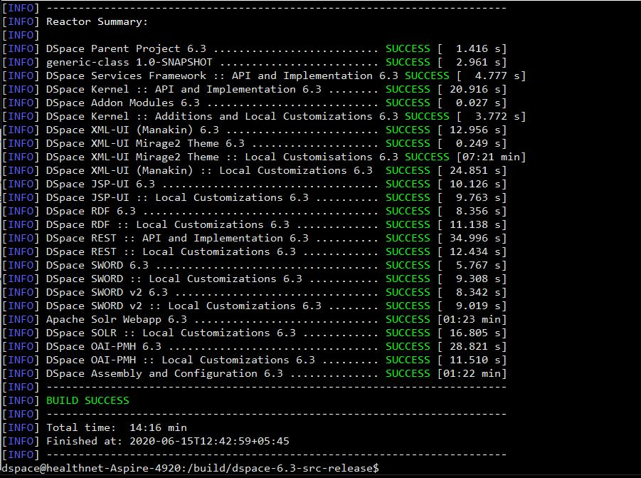

Change to the dspace/target/dspace-installer directory with the following command:

$ cd dspace/target/dspace-installer

Then finally install dsapce with ant

$ ant fresh_install

**Link tomcat8 to webapps directory**

Create file in **/etc/tomcat8/Catalina/localhost** such are name as xmlui.xml, jspui.xml, solr.xml, oai.xml etc.

For xmlui.xml add following code

<?xml version='1.0'?>

<Context

docBase="/dspace/webapps/xmlui"

reloadable="true"

cachingAllowed="false"/>

For jspui.xml add following code

<?xml version='1.0'?>

<Context

docBase="/dspace/webapps/jspui"

reloadable="true"

cachingAllowed="false"/>

For solr.xml add following code

<?xml version='1.0'?>

<Context

docBase="/dspace/webapps/solr"

reloadable="true"

cachingAllowed="false"/>

For oai.xml add following code

<?xml version='1.0'?>

<Context

docBase="/dspace/webapps/oai"

reloadable="true"

cachingAllowed="false"/>

$ mkdir /etc/tomcat8/webapps

$ sudo chmod -R 777 /etc/tomcat8/webapps

$ cp -R /dspace/webapps/* /etc/tomcat8/webapps*

$ /etc/init.d/tomcat8 restart

**Deploy DSpace**

Run the following commands as dspace user

$ /dspace/bin/dspace database migrate

$ /dspace/bin/dspace create-administrator

Open the browser and type [**http://localhost:8080/xmlui**](http://localhost:8080/xmlui)and your DSpace is live!

**DSpace 6.x with Mirage2 Customization**

Please follow the below instructions for Mirage2 theme style customization

* <https://wiki.lib.sun.ac.za/index.php/SUNScholar/XMLUI_Theme/M2/Customisation>

curl -sL https://dl.yarnpkg.com/debian/pubkey.gpg | gpg --dearmor | sudo tee /usr/share/keyrings/yarnkey.gpg >/dev/null

echo "deb [signed-by=/usr/share/keyrings/yarnkey.gpg] https://dl.yarnpkg.co m/debian stable main" | sudo tee /etc/apt/sources.list.d/yarn.list

sudo apt-get update && sudo apt-get install yarn

http://192.168.48..101:8080/xmlui